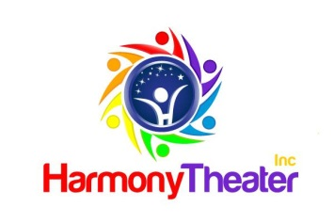
CALLING ALL HARMONY ACTORS &
FAMILY/FRIENDS OF HARMONY ACTORS!

You are Invited to Donate Hand-made

Creations to Support the

Harmony Scholarship Fund

HARMONY MARKETPLACE
AT THE
Purses, Bags and More Bingo
- Would you like to help HARMONY THEATER by donating your hand-made creations to the Harmony Marketplace?
- ALL proceeds benefit the Harmony Scholarship Fund
- Complete and return the form below BY OCTOBER 12, to Eileen Czekner, eczekner@yahoo.com
………………………………………………………………………………….
HARMONY ACTORS COMPLETE THIS SECTION:  Harmony Actor’s Name:  Item to Sell:  Price per Item:  How long have you been in Harmony Theater?  What do you like about Harmony Theater?  What ONE other hobby or interest do you enjoy? | FAMILY/FRIENDS OF HARMONY ACTORS COMPLETE THIS SECTION:  Harmony Actor’s Name:  Item to Sell:  Price per Item:  Item Hand-made by (Name):  Relation to Harmony Actor – Family  Friend:
………………………………………………………………………………….
*** This is a donation of goods. Any money made will go to Harmony Theater. ***
*** Family/Friends of Harmony Actors will not make money on the sale of their items. ***

PLEASE bring your Market Items to rehearsal BY OCTOBER 12, PRE-PACKAGED and in a labeled
DISPLAY BASKET or TRAY (so we can return it to you).
We will create a sign with your Actor’s name, your name, item name, and item price.

